**Basic Programming Assignment Meeting 5**



**From:**

AL AZHAR RIZQI RIFA’I FIRDAUS

**Class:**

1 I

**Absence:**

01

**Major:**

Information Technology

**Study Program:**

Informatic Engineering

**Assignment 1**

To avoid fraud committed by photocopied employees when serving customers, a photocopy owner makes a flowchart to calculate the costs to be paid, so that customers can know the calculations clearly and transparently. If someone makes photocopies with more than 100 copies, then he or she gets a photocopy price of IDR 100 per sheet. Meanwhile, apart from that, he gets a photocopy price of IDR 150 per sheet. Help the photocopy owner to make the flowchart!

Result :

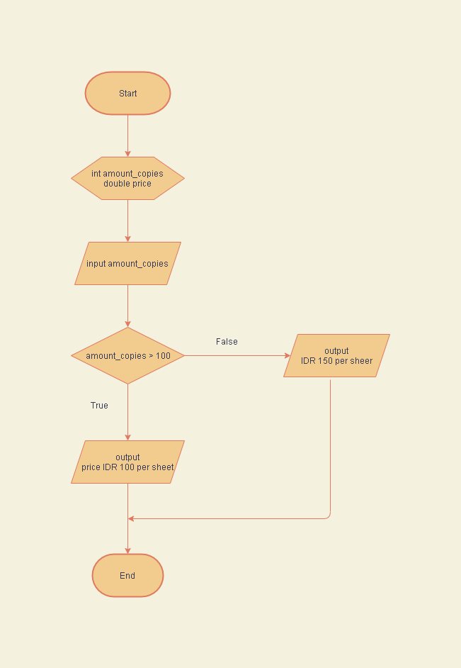

**Assignment 2**

Indonesia Merdeka is one of the shops in Malang which is very crowded with buyers because it is famous for the quality of the products it sells. Every Friday, the shop gives a bonus to customers who buy Indonesian-made electronic goods according to the total purchase. If the total purchase from this customer is more than or equal to IDR 500.000, the bonus that the customer will get is an iron. If the total purchase is less than IDR 500.000, the bonus the customer gets is an umbrella. Create the flowchart!

Result :

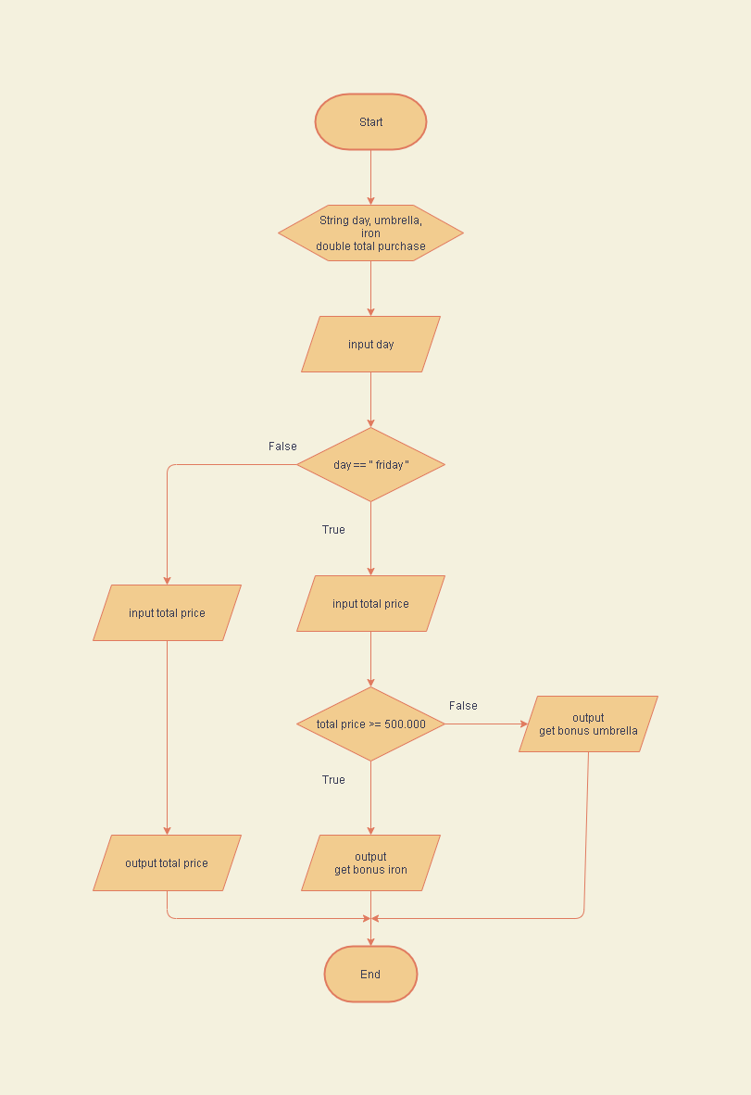

**Assignment 3**

In a calculation program, it is known that the value of P = x + y. The user enters two numbers x and y. After performing the calculations, if P is positive, then the value of Q = x * y. If not, then the value Q = x / y. Create the flowchart!

Result :

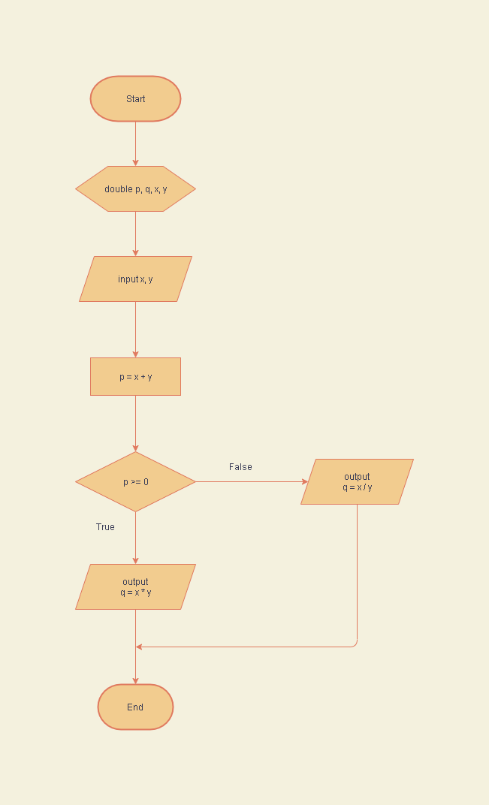

**Assignment 4**

One form of love for the environment is throwing garbage in its place. The following is a picture of waste bins that are differentiated based on the type of waste to be disposed of. Make a flowchart to help someone choose a waste bin when throwing garbage based on the type!

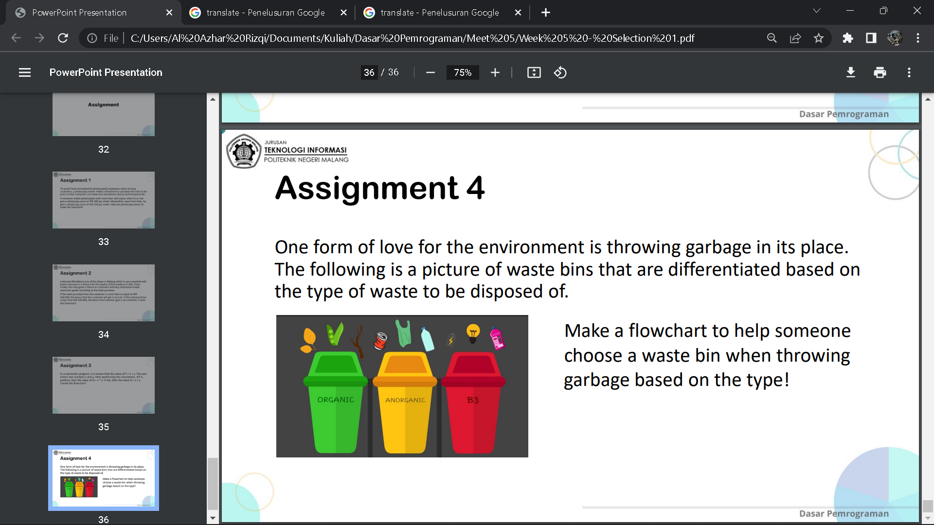

Result :

